The Story Behind the Creation of Rosenberg eBooks

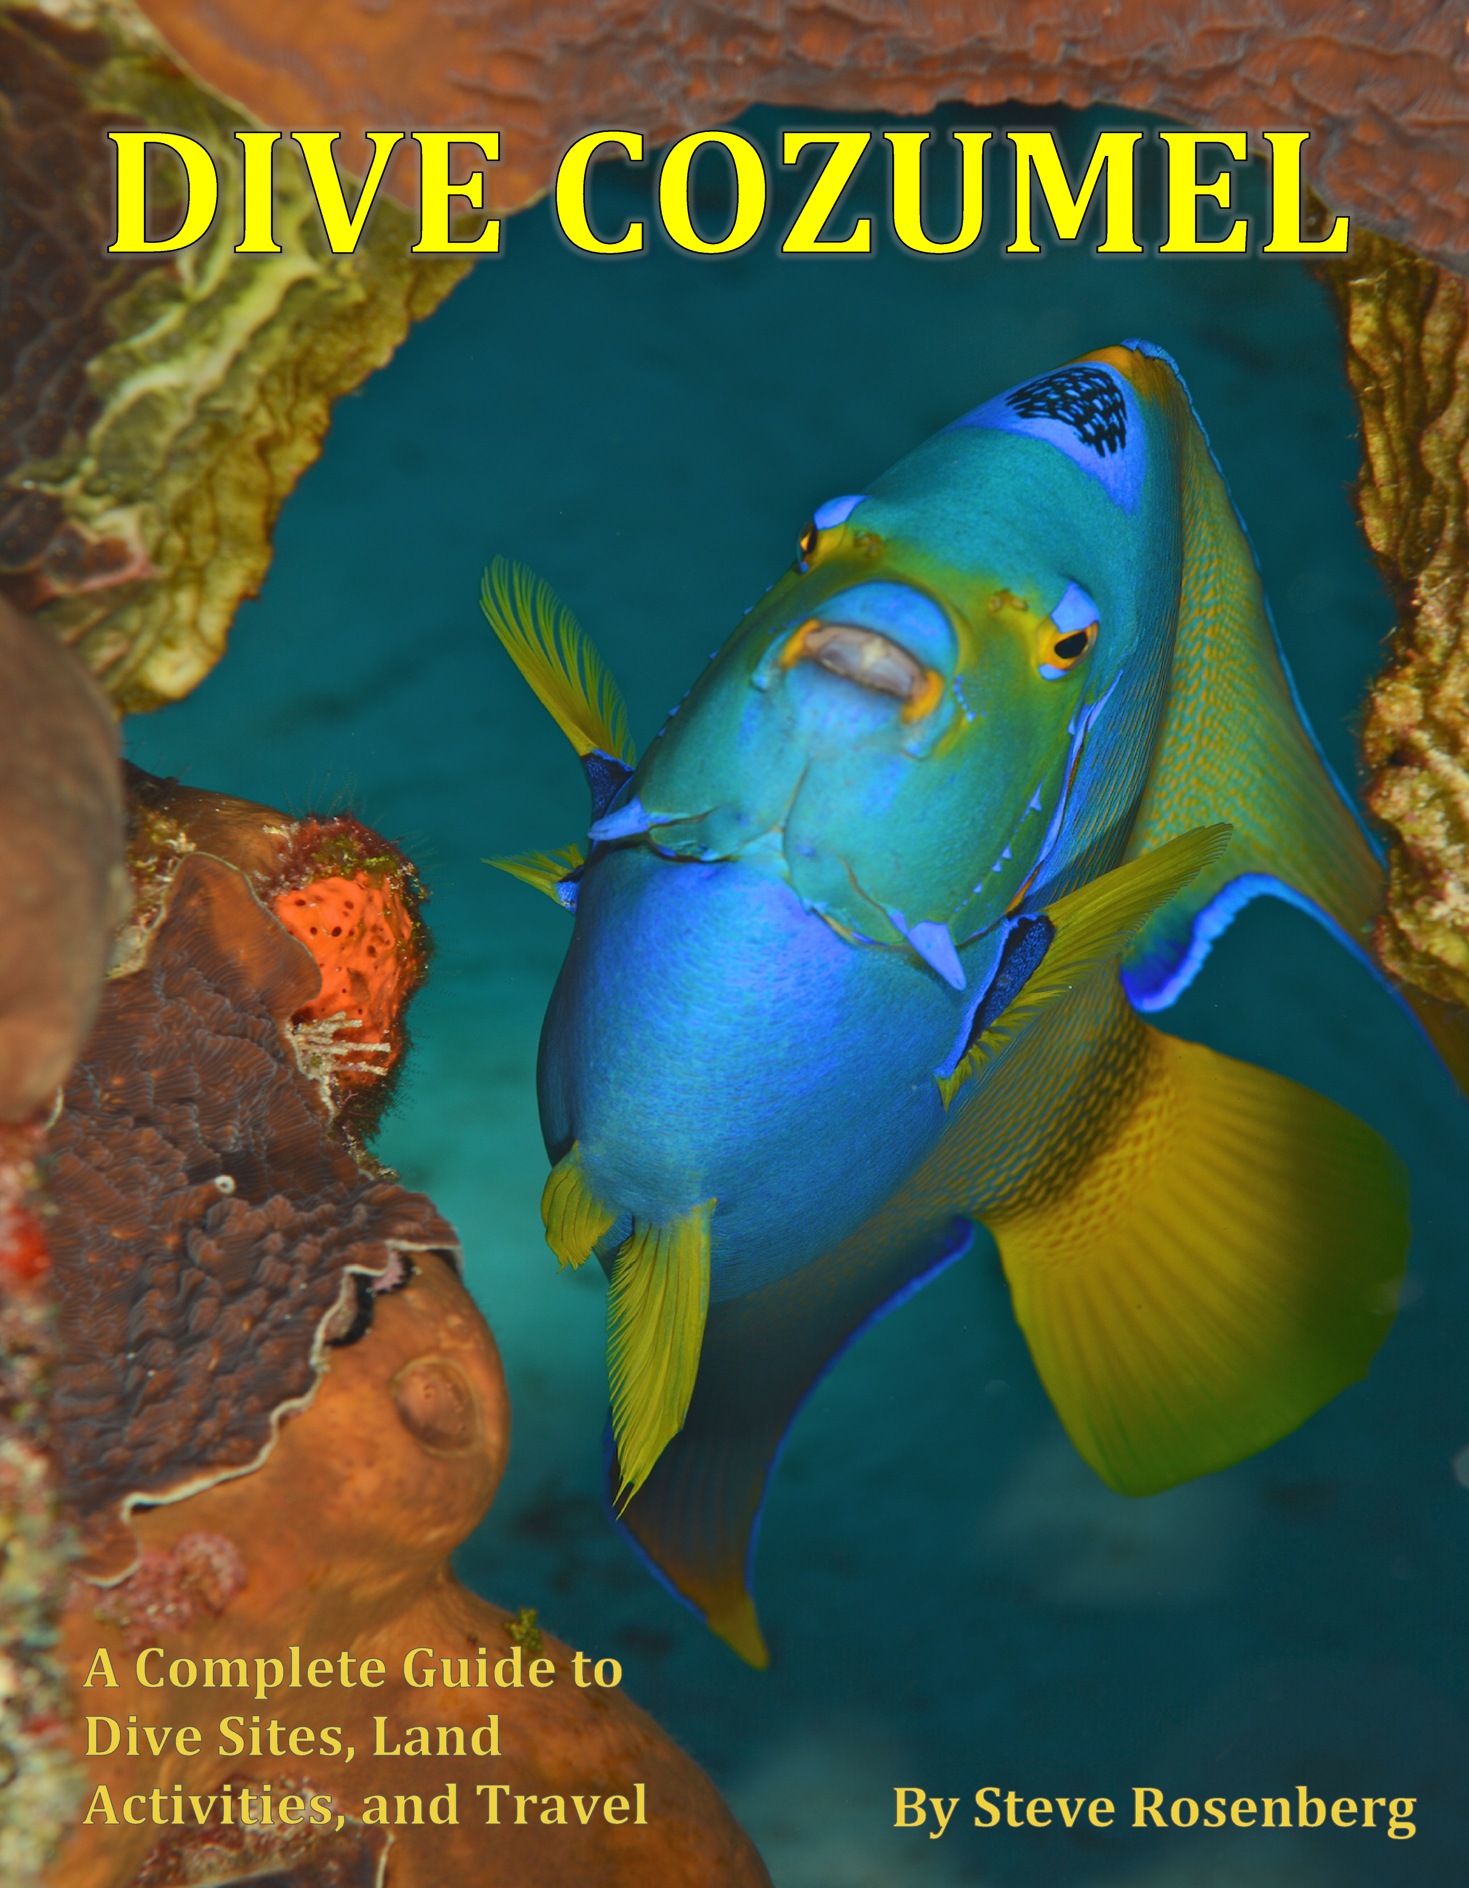

Youtube link for Dive Cozumel video: http://youtu.be/lwqNied_ri0

Steve Rosenberg began diving in the early 1970’s and quickly became enamored with the beauty and excitement to be found beneath the surface of the ocean. While actively engaged in the practice of law in northern California, he began a second career in 1980 as a professional underwater photographer and photojournalist. Since that time he has produced over 20 destination guidebooks for international publishers including Lonely Planet, Cruising Guides and Aqua Quest Publications. He has written hundreds of articles for various U.S. and International publications.
In the late 1980’s Steve put together and operated a retail Scuba Diving trade show, in Oakland, California. Under his direction, Seaviews quickly became one of the largest and most successful scuba shows in the United States and drew over 10,000 divers annually for over 10 years.
Thousands of his images have appeared in books and magazines worldwide, and he has also won more than 250 awards for his imagery in international competitions, including gold medals in the prestigious Hans Hass Photo Competition in Austria and the First World UW Photography Competition held in the Turks and Caicos Islands in 1997. In 1996 Steve received the coveted Scuba Schools International SSI Platinum Pro 5000 certification, awarded to divers with 5000 or more dives. He is an active member of the Society of American Travel Writers SATW and the North American Travel Journalists Association NATJA.
In 2011, Steve joined ReefID.org, a new on-line marine life identification enterprise founded by John Fifer, which also specialized in developing cell apps for aquariums, dive resorts and dive destinations. Steve served as the executive editor and photo pro for ReefID.

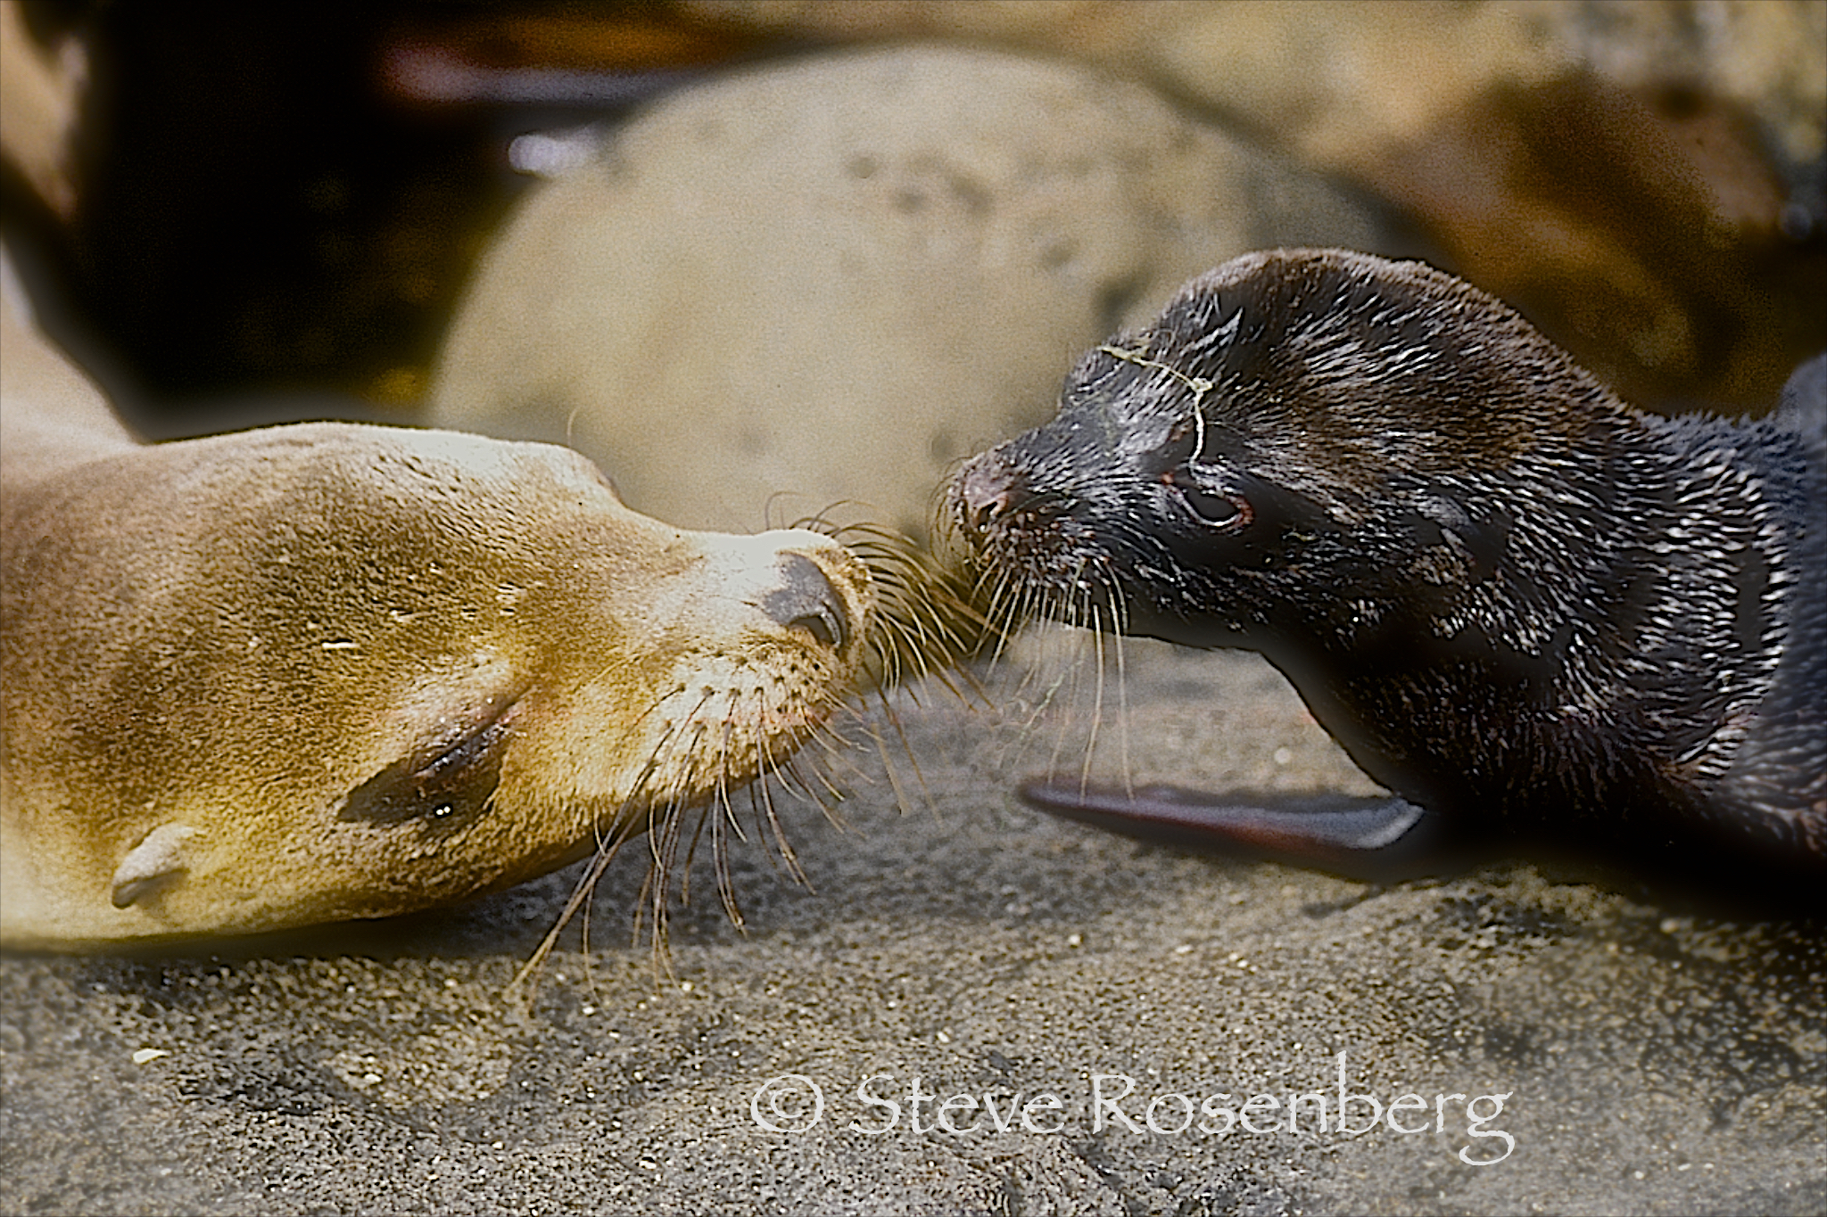
In 2012, Steve Rosenberg and Ken Weemhoff, a pioneer in the Galápagos dive travel industry, formed a new company, Dive Galápagos. This company continues to be the ultimate resource on the Galápagos, including two new books on diving and travel to the Galápagos written and illustrated by Steve Rosenberg, and a full service dive travel company that works with numerous dive shops, tour companies and dive clubs to assist them with organizing Galapagos tours for their clients. For more information go to the website at www.diveglapagos.com.

In 2013, Steve assembled a new team of professionals for the purpose of producing interactive eBooks to be used as scuba and travel guides, as well as powerful marketing tools for destinations, resorts and live-aboard operations. To date, this company, Rosenberg Ebooks, has published three comprehensive dive and travel guides. The most recent guide is Dive Cozumel, which was released in November 2014. For more information go to the website http://www.rosenbergebooks.com

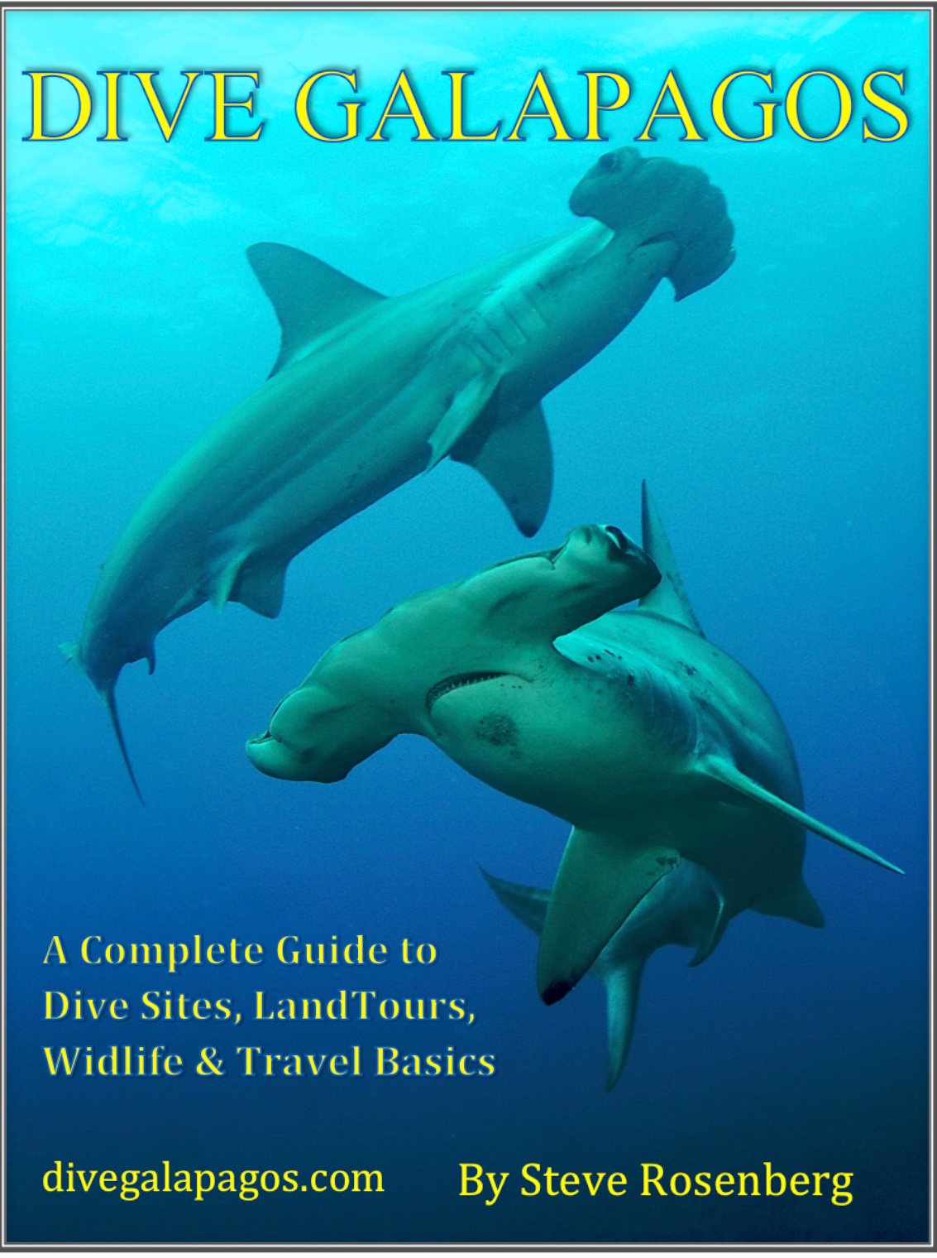

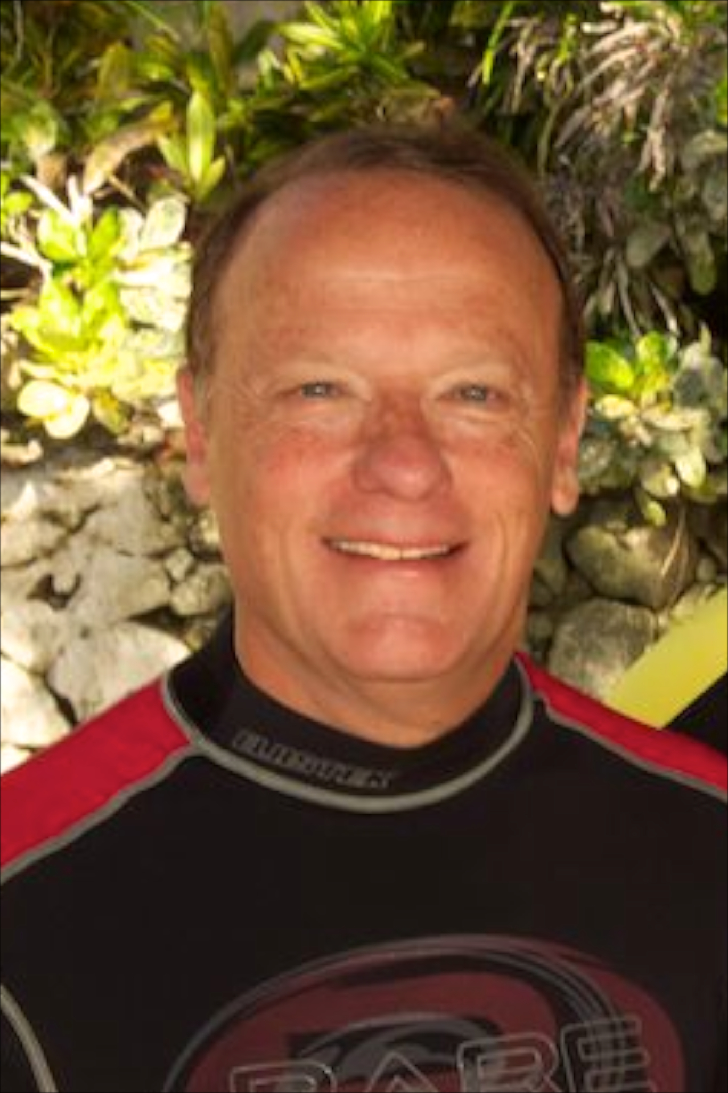
Conservation Statement

I have been diving for over 40 years. During that time I have seen devastating changes in the ocean. Certainly, much of the damage has been caused by over fishing, lack of enforcement of existing regulations and collateral damage from commercial development. I believe that the community of photographers and videographers are ambassadors for the oceans. It is not enough that we raise the level of awareness of the beauty and wonders to be found in the Sea, but I believe we also have an obligation to set an example for others, divers and non-divers alike. We need to respect our reefs and marine life, and promote action that will preserve our seas.

